**Lab # 04**

**Name:Muhammad Hassam khan**

**s.id: 11141**

**Q1**

**CODE:**

INCLUDE Irvine32.inc

.data

.code

main PROC

mov eax,10

mov ecx,10

mov ebx,20

cmp eax,ebx

JNE L1

L1:

inc eax

cmp eax,ebx

JE L2

loop L1

call readint

L2:

call writeint

call crlf

exit

main ENDP

ENd main

**SCREENSHOT:**

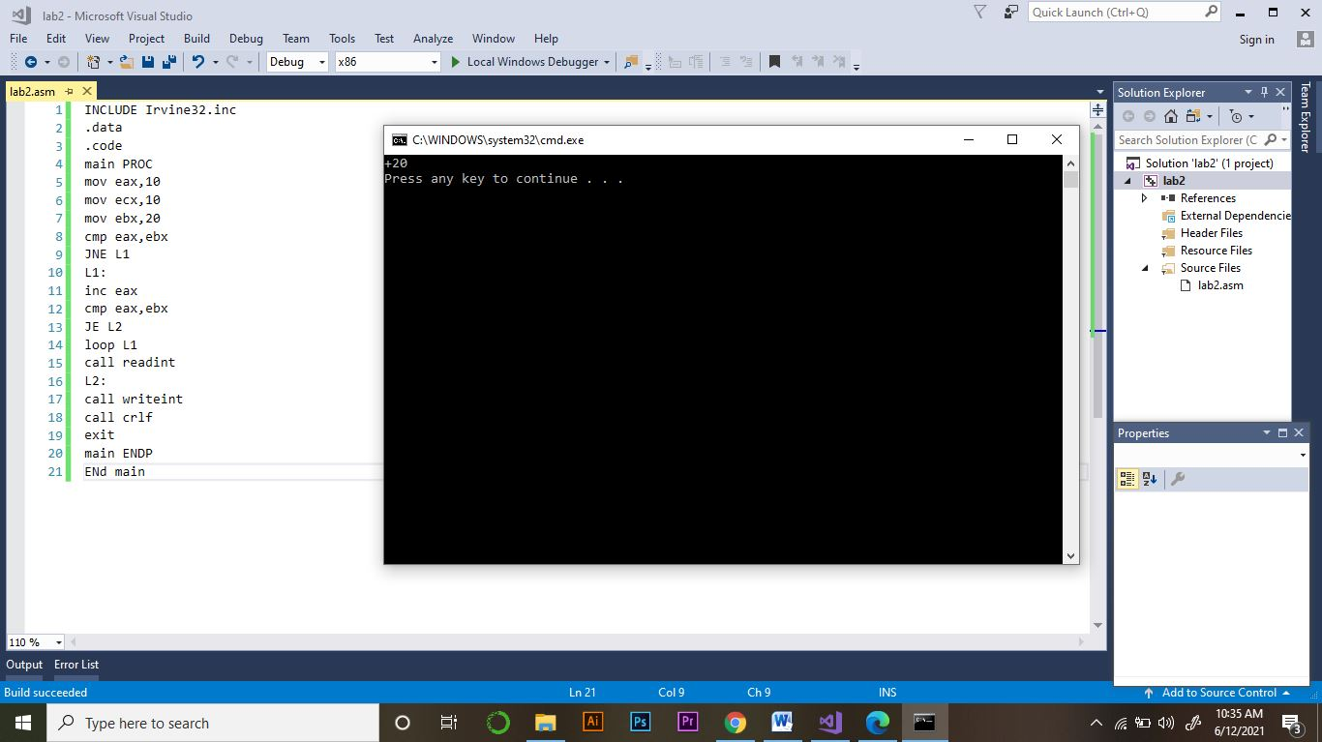

Q2:

CODE:

INCLUDE Irvine32.inc

.data

n1 DWORD 47

n2 DWORD 22

n3 DWORD 31

answer DWORD ?

.code

main PROC

mov eax,n1

mov answer,eax

cmp eax,n2

jge L1

mov eax,n2

mov answer,eax

L1:

mov eax,answer

cmp eax,n3jge L2

mov eax,n3

mov answer,eax

L2:

call writedec

call crlf

exit

main ENDP

ENd main

**SCREENSHOT:**

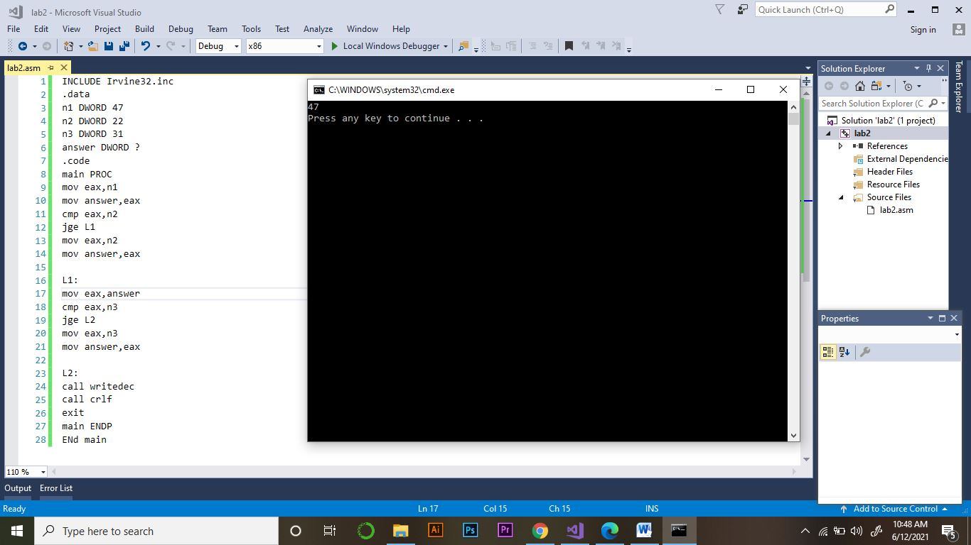

**Q3:**

**CODE:**

INCLUDE Irvine32.inc

.data

.code

main PROC

mov eax,0mov ecx,20

mov ebx,20

L1:

mov eax,ebx

call writedec

dec ebx

call crlf

loop L1

call readint

exit

main ENDP

ENd main

**SCREENSHOT:**

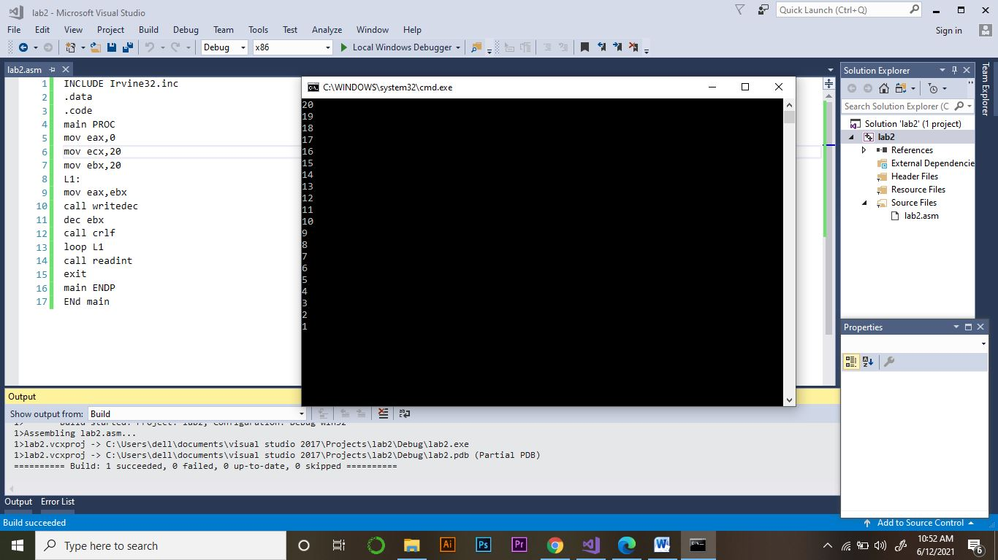

**Q4**

**CODE:**

INCLUDE Irvine32.inc

.data .code

main PROC

mov eax,0

mov ecx,4

L1:

inc eax

mov edx,eax

cmp eax,3

JE L2

call writeint

call crlf

loop L1

L2:

mov eax,0

add edx,1

mov eax,edx

call writeint

call crlf

loop L2

exit

main ENDP

ENd main

**SCREENSHOT:**

